BETHALTO COMMUNITY UNIT DISTRICT # 8
SLO Growth Data Sheet

Educator Name:

SLO # 1

Course/Subject:

Grade Level:

SLO # 1 Describe the learning goal (type 2 and type 3 assessments):

SLO # 1 Identify content standards associated with the learning goal (type 2 and type 3 assessments):

SLO #1 Describe the student population:

SLO #2

Course/Subject:

Grade Level:

SLO #2 Describe the learning goal (type 2 and type 3 assessments):

SLO # 2 Identify content standards associated with the learning goal (type 2 and type 3 assessments):

SLO #2 Describe the student population (may be the same as SLO #1):

SLO #1  Pre Assess. Date: ____/____/____  Post Assess. Date: ____/____/____  Class: _________________________  Assessment: ____________________ |  |  |  |  | SLO #2  Pre Assess. Date: ____/____/____  Post Assess. Date: ____/____/____  Class: _________________________  Assessment: ____________________
Name (First) | Pre | Post | Growth |  | Name (First) | Pre | Post | Growth

Total Students: _______________________ Total Students: _______________________

Number Showing Growth: _____________ Number Showing Growth: ____________

SLO 1 Percent Growth: _________________ SLO 2 Percent Growth: ________________

Average Growth

($SLO 1+SLO 2) ÷2 =$ ________________________

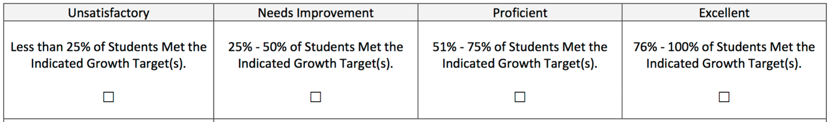

The chart below is used to determine your final summative rating based on the practice and student growth components of the evaluation.

